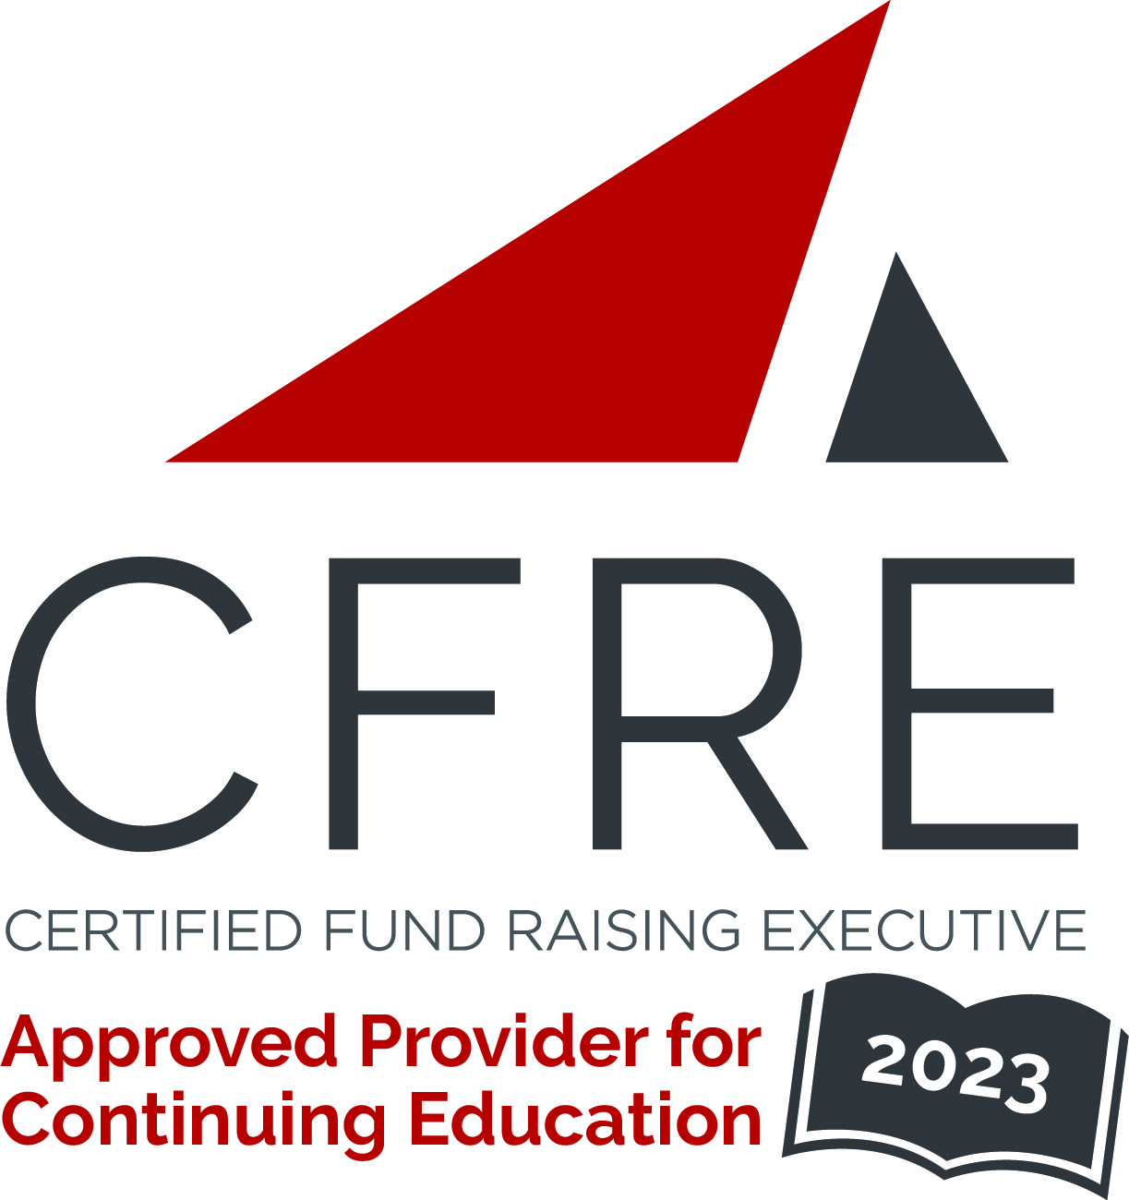  CFRE International has developed this form as a way for you to quickly track (and keep in your files!) the continuing education sessions you have attended. Simply check the boxes next to the sessions you attended. At the end of the conference, add up the total number of hours. Keep this sheet and you will be ready to complete your application form. All of the session slots listed are eligible for continuing education points on your CFRE application for initial certification and/or recertification. Sessions not listed here are not eligible for points. |  | CONTINUING EDUCATION POINTS TRACKER

Activity Organizer: - GoalBusters Consulting
Title of Activity: - GoalBusters Small and Mighty Fundraising Conference
Names of Presenter(s): - Various
Dates and Location: - 24 August, 2023 – Prescott, AZ USA

Date: 24 August, 2023
Session 1: 8:45am – 9:45am (1 pt)
- From Accidental Fundraiser to Servant Fundraiser: $90M of Philanthropy at Lowell Observatory

Date: 24 August, 2023
Session 2: 10:00am – 11:15am (1.25 pts)
- Ideal Steps to Win Grants
- Your Most Critical (Often Overlooked) To-Do Item – Your Marketing Plan
- Servant Fundraising – How the Tenets of Servant Leadership Boost Fundraising Results

Date: 24 August, 2023
Session 3: 12:00pm – 12:50pm (1 pt)
- Finding Time for Fundraising (or your ‘other duties as assigned’)

Date: 24 August, 2023
Session 4: 1:30pm – 2:45pm (1.25 pts)
- Dating Your Donors: The Do’s and Don’ts
- Building a Better Board: 3 I’s of Board Engagement
- Unlocking the Power of AI: How Communication Professionals can Leverage Artificial Intelligence for Success

Date: 24 August, 2023
Session 5: 3:00pm – 4:00pm (1 pt)
- Unlocking the Power of Your Working Genius

Total number of points attained: __________

